
Study Buddy /Group: 7

Study Buddy
Software Design Specification (SDS)
Version: 1.3
CM Identifier: SDS_V1.3

Revision History

Sl. No. | Prepared/  Modified by | E-mail | Version | Date | Approved by | Descriptions/  Remarks
1. | Khaled Sameh | KhaledSamehMohamed@hotmail.com | 1.0 | 7-Apr-2018 | Moaz Alaa | 1. Introduction  4. Data Models
2. | Moaz Alaa | Moaz_elshorbagy@hotmail.com | 1.1 | 8-Apr-2018 | Khaled Sameh | 2. System Architecture  3. Design Models  5. System Deployment
3. | Khaled Sameh | KhaledSamehMohamed@hotmail.com | 1.2 | 8-Apr-2018 | Moaz Alaa | 6. Traceability of Requirements
4. | Amin Ghassan | amin_ghassan@hotmail.com | 1.3 | 9-Apr-2018 | Moaz Alaa | 3.2.2 Class Diagram of View Subsystem.

Distribution list
Name | E-mail | Notes
Eng. Ali El-Seddeek | alielseddeek@gmail.com | -
Eng. Dina El-Reedy | dinaelreedy@gmail.com | -

Table of Contents

1. Introduction 6
1.1 Purpose of this Document 6
1.2 Scope 6
1.3 Table of Acronyms and Definitions 6
1.4 References 7
1.5 Overview of Document 8
2. System Architecture 8
3. Design Models 9
3.1 Design Patterns Description 9
3.2 Class Diagrams 10
3.3 Interaction Diagrams 12
4. Data Models 14
5. System Deployment 19
Traceability to Requirements 20

List of Tables

Table 1 - Table of Acronyms and Definitions 7
Table 2- Table of Requirement Identification 20
Table 3 – Traceability Matrix 20

List of Figures
Figure 1- Layered System Architecture 8
Figure 2 - MVC Design Pattern 9
Figure 3 - Class Diagram of the Control Subsystem 10
Figure 4 - User Sign-up Sequence Diagram 12
Figure 5 - User Log-in Sequence Diagram 12
Figure 6 - Search Books Sequence Diagram 13
Figure 7 - Lend Book Sequence Diagram 14
Figure 8 - Entity-Relationship Diagram (ERD) 15
Figure 9 - Component Diagram Modeling the System’s Dependencies 19
Figure 10 - System Deployment Diagram 19

Introduction

Purpose of this Document
This document will define the design of Study Buddy website. It contains specific information about the expected inputs and outputs of the application and the class that will be used and their interaction with each other to reach the needed requirements, all this is outlined in detail at the end of this document

Scope
The purpose of the project is to create a centralized database system, and modules that will help the user look for the needed books and/or tools with ease, also to donate any book/tool the user wishes to give up for free through a website using their computers or mobile phones.
This document provides the architecture and design of Release 1.0 of the Study Buddy website. And it will show how the design will accomplish the functional and non-functional requirements detailed in the Software Requirements Specification (SRS) document.

Table of Acronyms and Definitions

Term | Definition
Engineering Student | A person who will access the web page and use it to perform the trade he wishes, whether it be borrowing, lending, requesting a book or engineering tool.
Software design specification | Also known as SDS document, is a document that contains the description of a software product, that a software designer writes in order to give a software development team overall guidance to the architecture of the software project.
Stakeholder | Any person with an interest in the project and is affected by it who is not a developer.
Database | Collection of information that are of use inside the system (E.g. book names, students information…).
Teaching Assistant | A person who is not a student but has the right to look for a book if needed in certain post graduate studies or to prepare for giving a tutorial.
Engineering Tools | Tools that used by engineers (E.g. T-Ruler, compass, eraser shield, drawing board, triangular rulers).
Professors | A member of the teaching staff who can use this software to either help the students and guide them by giving them books, or can use it to borrow books for reasons similar to those of the Teaching Assistants’.
User | Student, Teaching Assistant, or Professor.  People who potentially use the software to gain benefit from it.
Entity-Relationship diagram | Also known as E-R diagram, is used to describe all the entities pointing out their attributes (Properties) and how they interact with each other
Communication diagrams | Such as the UML diagram (Unified modelling language), are a collection of diagrams used to visualize a software program, showing the interactions between objects in sequence, describing both the static and dynamic behavior of the system
Entity | A representation of a real object in the system of software, so that we can model it and perform operations on/with it.
Attributes | Properties of the entities, i.e. what defines them and makes them different from each other.
Cart | A virtual holder for the books or tools so that we can perform a certain transaction on them.
Relationship | Its meaning here is the interaction between entities and it’s properties.
Cardinality of a relationship | I.e. one to one, Many to one. The number of possible entities on one side that can interact with another possible number of entities on the other side of a relationship. E.g. one user can donate more than one book so the cardinality of this relationship is one user to many books, one to many.
Unique attribute | An attribute that is not repeated in any two entities (Like a username).
Donation | When a user decides to give his book/tool for a period of time so that other users can borrow it.
Table 1 - Table of Acronyms and Definitions

References

[1] “Software Engineering”, 9th Edition, Ian Somerville, Pearson, 2011
https://edisciplinas.usp.br/pluginfile.php/2150022/mod_resource/content/1/1429431793.203Software%20Engineering%20by%20Somerville.pdf .
- “Software Engineering”, 7th Edition, Ian Sommerville, Addison-Wesley, 2004
- ”The Unified Modeling Language User Guide”, Grady Booch, James Rumbaugh, Ivar Jacobson, Addison-Wesley, 1998
- “Mastering UML with Rational Rose 2002”, Wendy Boggs, Michael Boggs, SYBEX, 2002
- “Patterns of Enterprise Application Architecture”, Martin Fowler, Addison Wesley, 2002
- Software Engineering Course Lecture Notes, Dr. El Sayed Hemayed.

Overview of Document
The second part of the SDS document will describe the architecture of the system and what are the components of the system, this will be described using various diagrams and structural models to show the relationships between users and system objects.
The third section of the document will talk about data objects in the system and how they are controlled and their relationships with each other, in brief it will explain the dynamics of the system and how to it can be manipulated.
The fourth section of the document will show the data models and how they are diagramed with all their attributes.
The fifth section will talk about the deployment of the system and how it will work using various diagrams and models. Also it will discuss the runtime and execution of the system, and how the components worked out.
The sixth and last section will trace the requirements to design elements to show which requirements were met, and which will be finished later on in the next versions.

System Architecture
The figure represents a layered architecture that is used to model the interfacing between subsystems, each layer provides a set of services as shown.
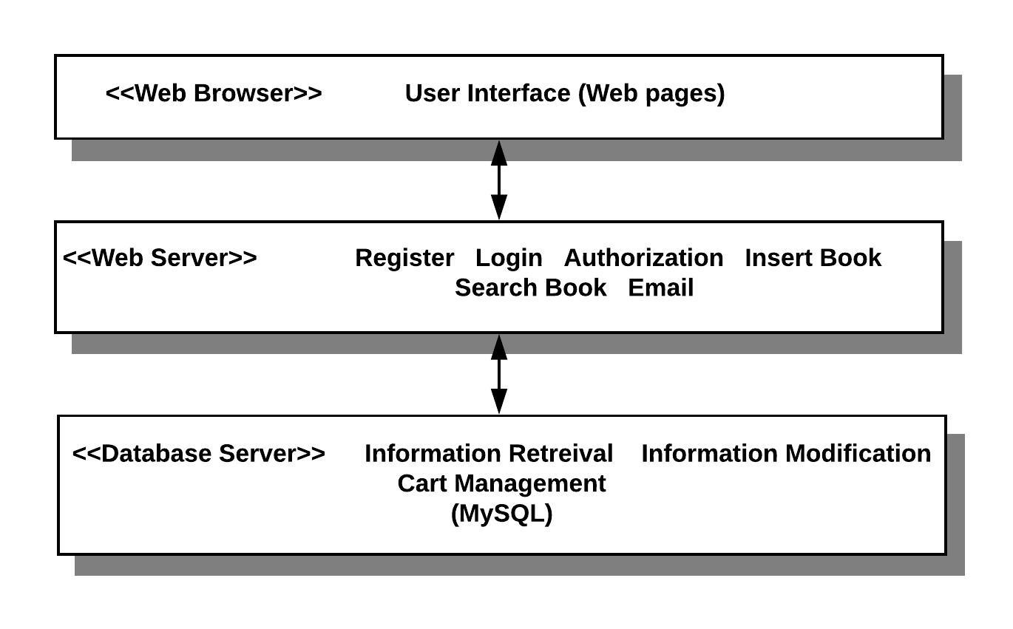
Figure 1- Layered System Architecture

The subsystems represented as <<subsystem>> are controlled by event-based control because the system is centered on performing actions in response to user input, the flow of the program is determined by events such as user actions since we’re using a graphical user interface.

Design Models

Design Patterns Description

Model-View-Controller (MVC)
The system is structured into three logical components that interact with each other.
It is used because we have multiple ways to view and interact with data according to each user.
It’s a dynamic website; the data changes very often, so using MVC will help because data is an independent component. It also provides three layers which can increase the security of users’ data because it’s in the inner-most layer.

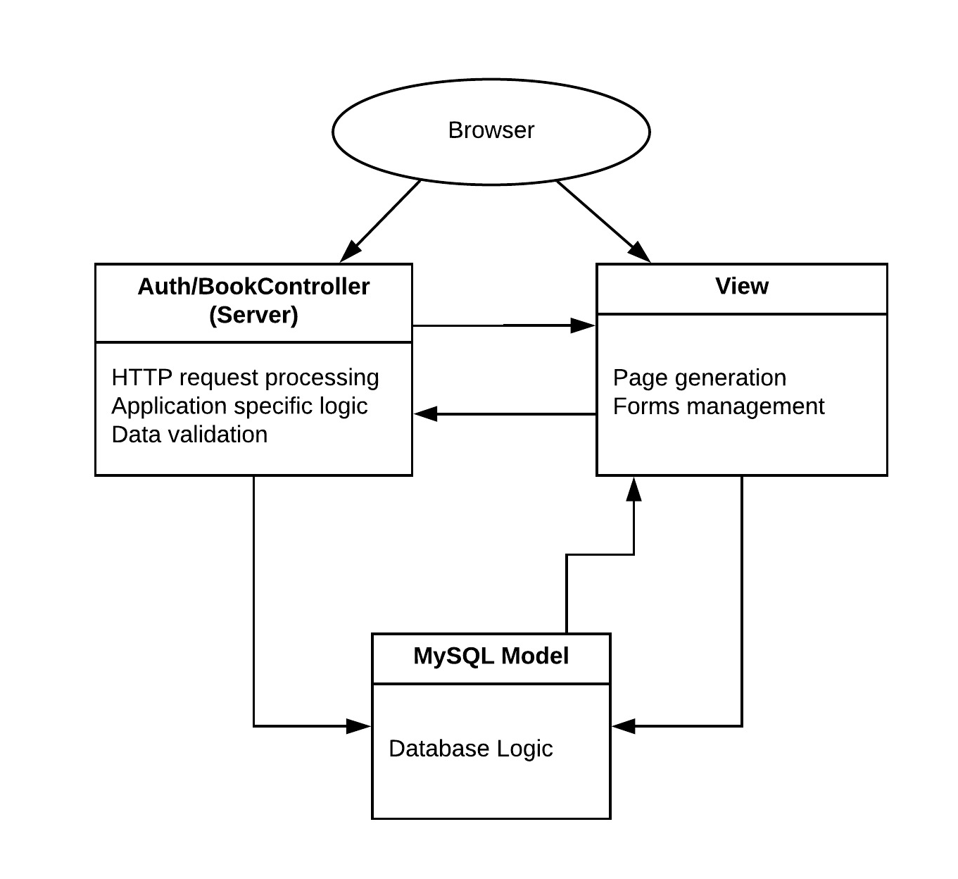
Figure 2 - MVC Design Pattern

Class Diagrams
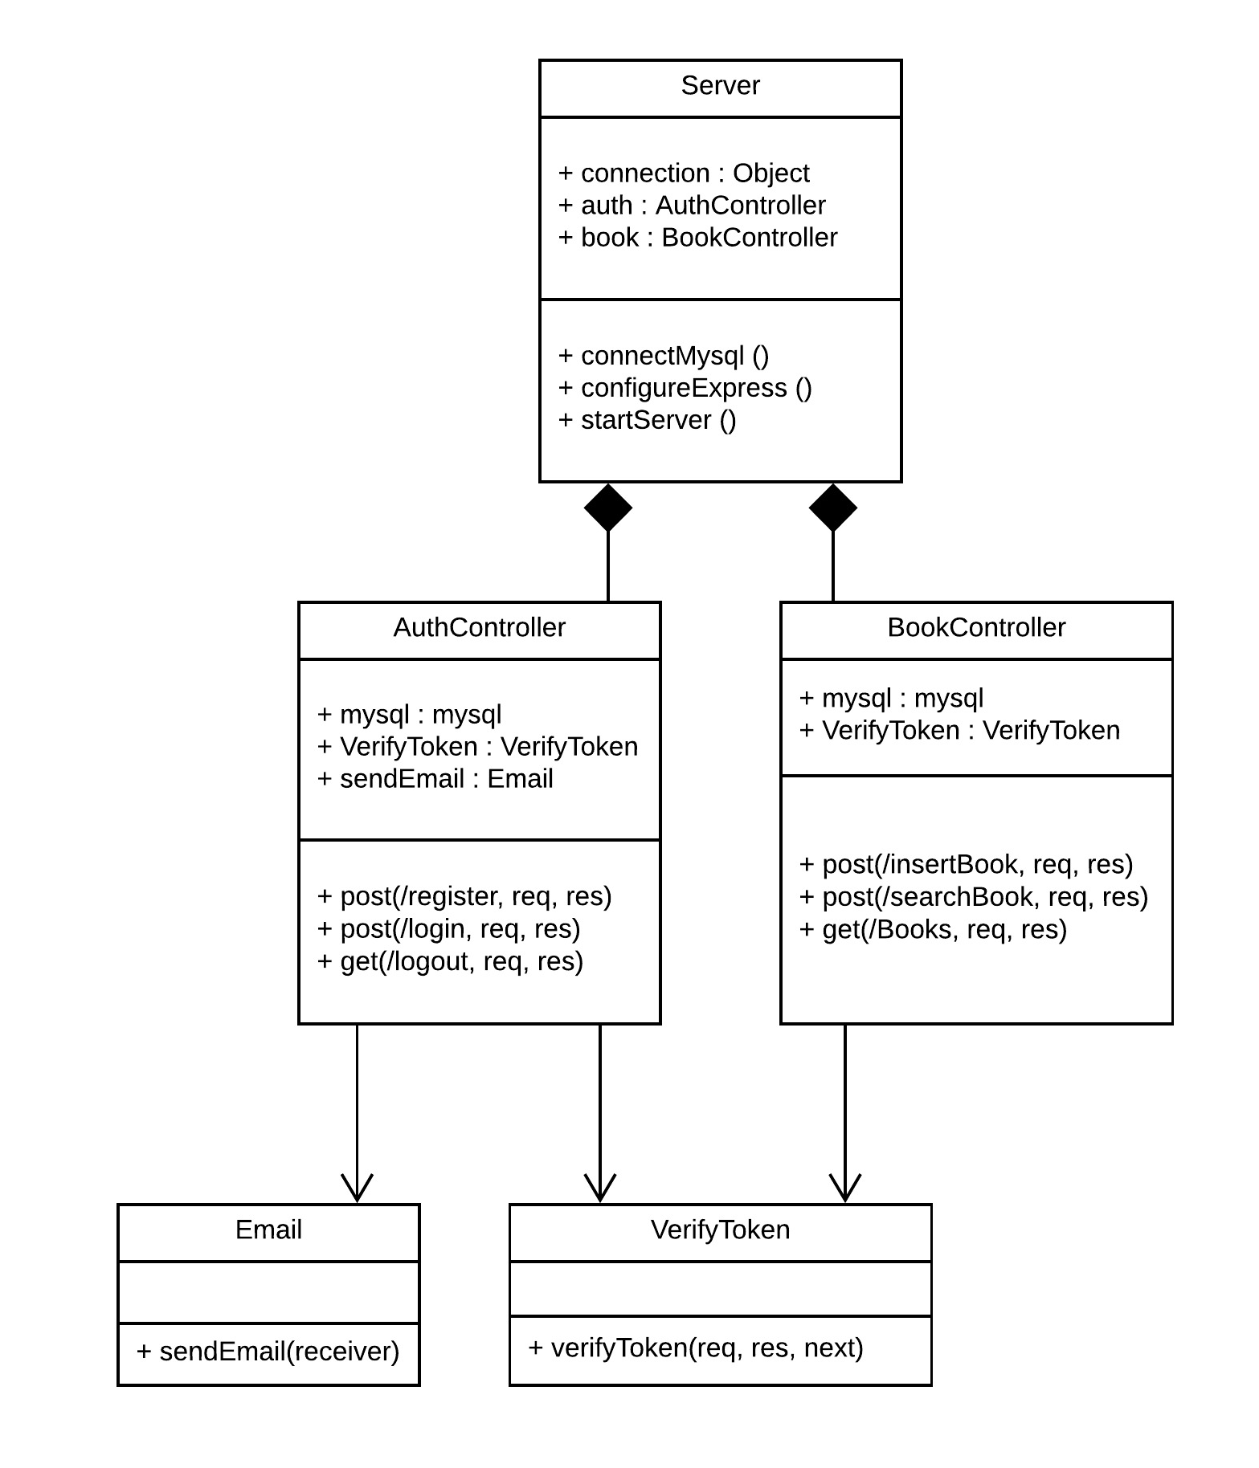
Figure 3 - Class Diagram of the Control Subsystem – ID: C01

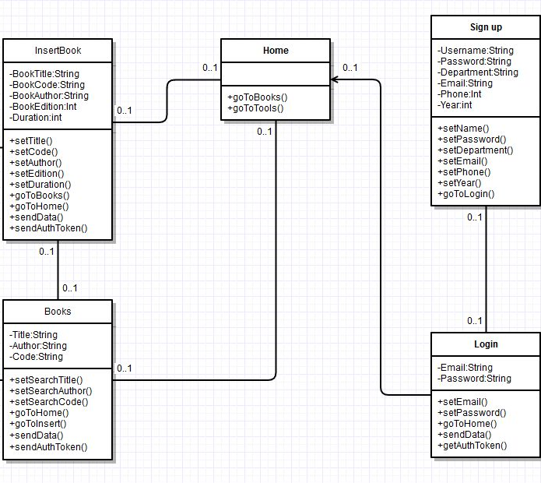
Figure 4 - Class Diagram of View – ID: C02

Interaction Diagrams
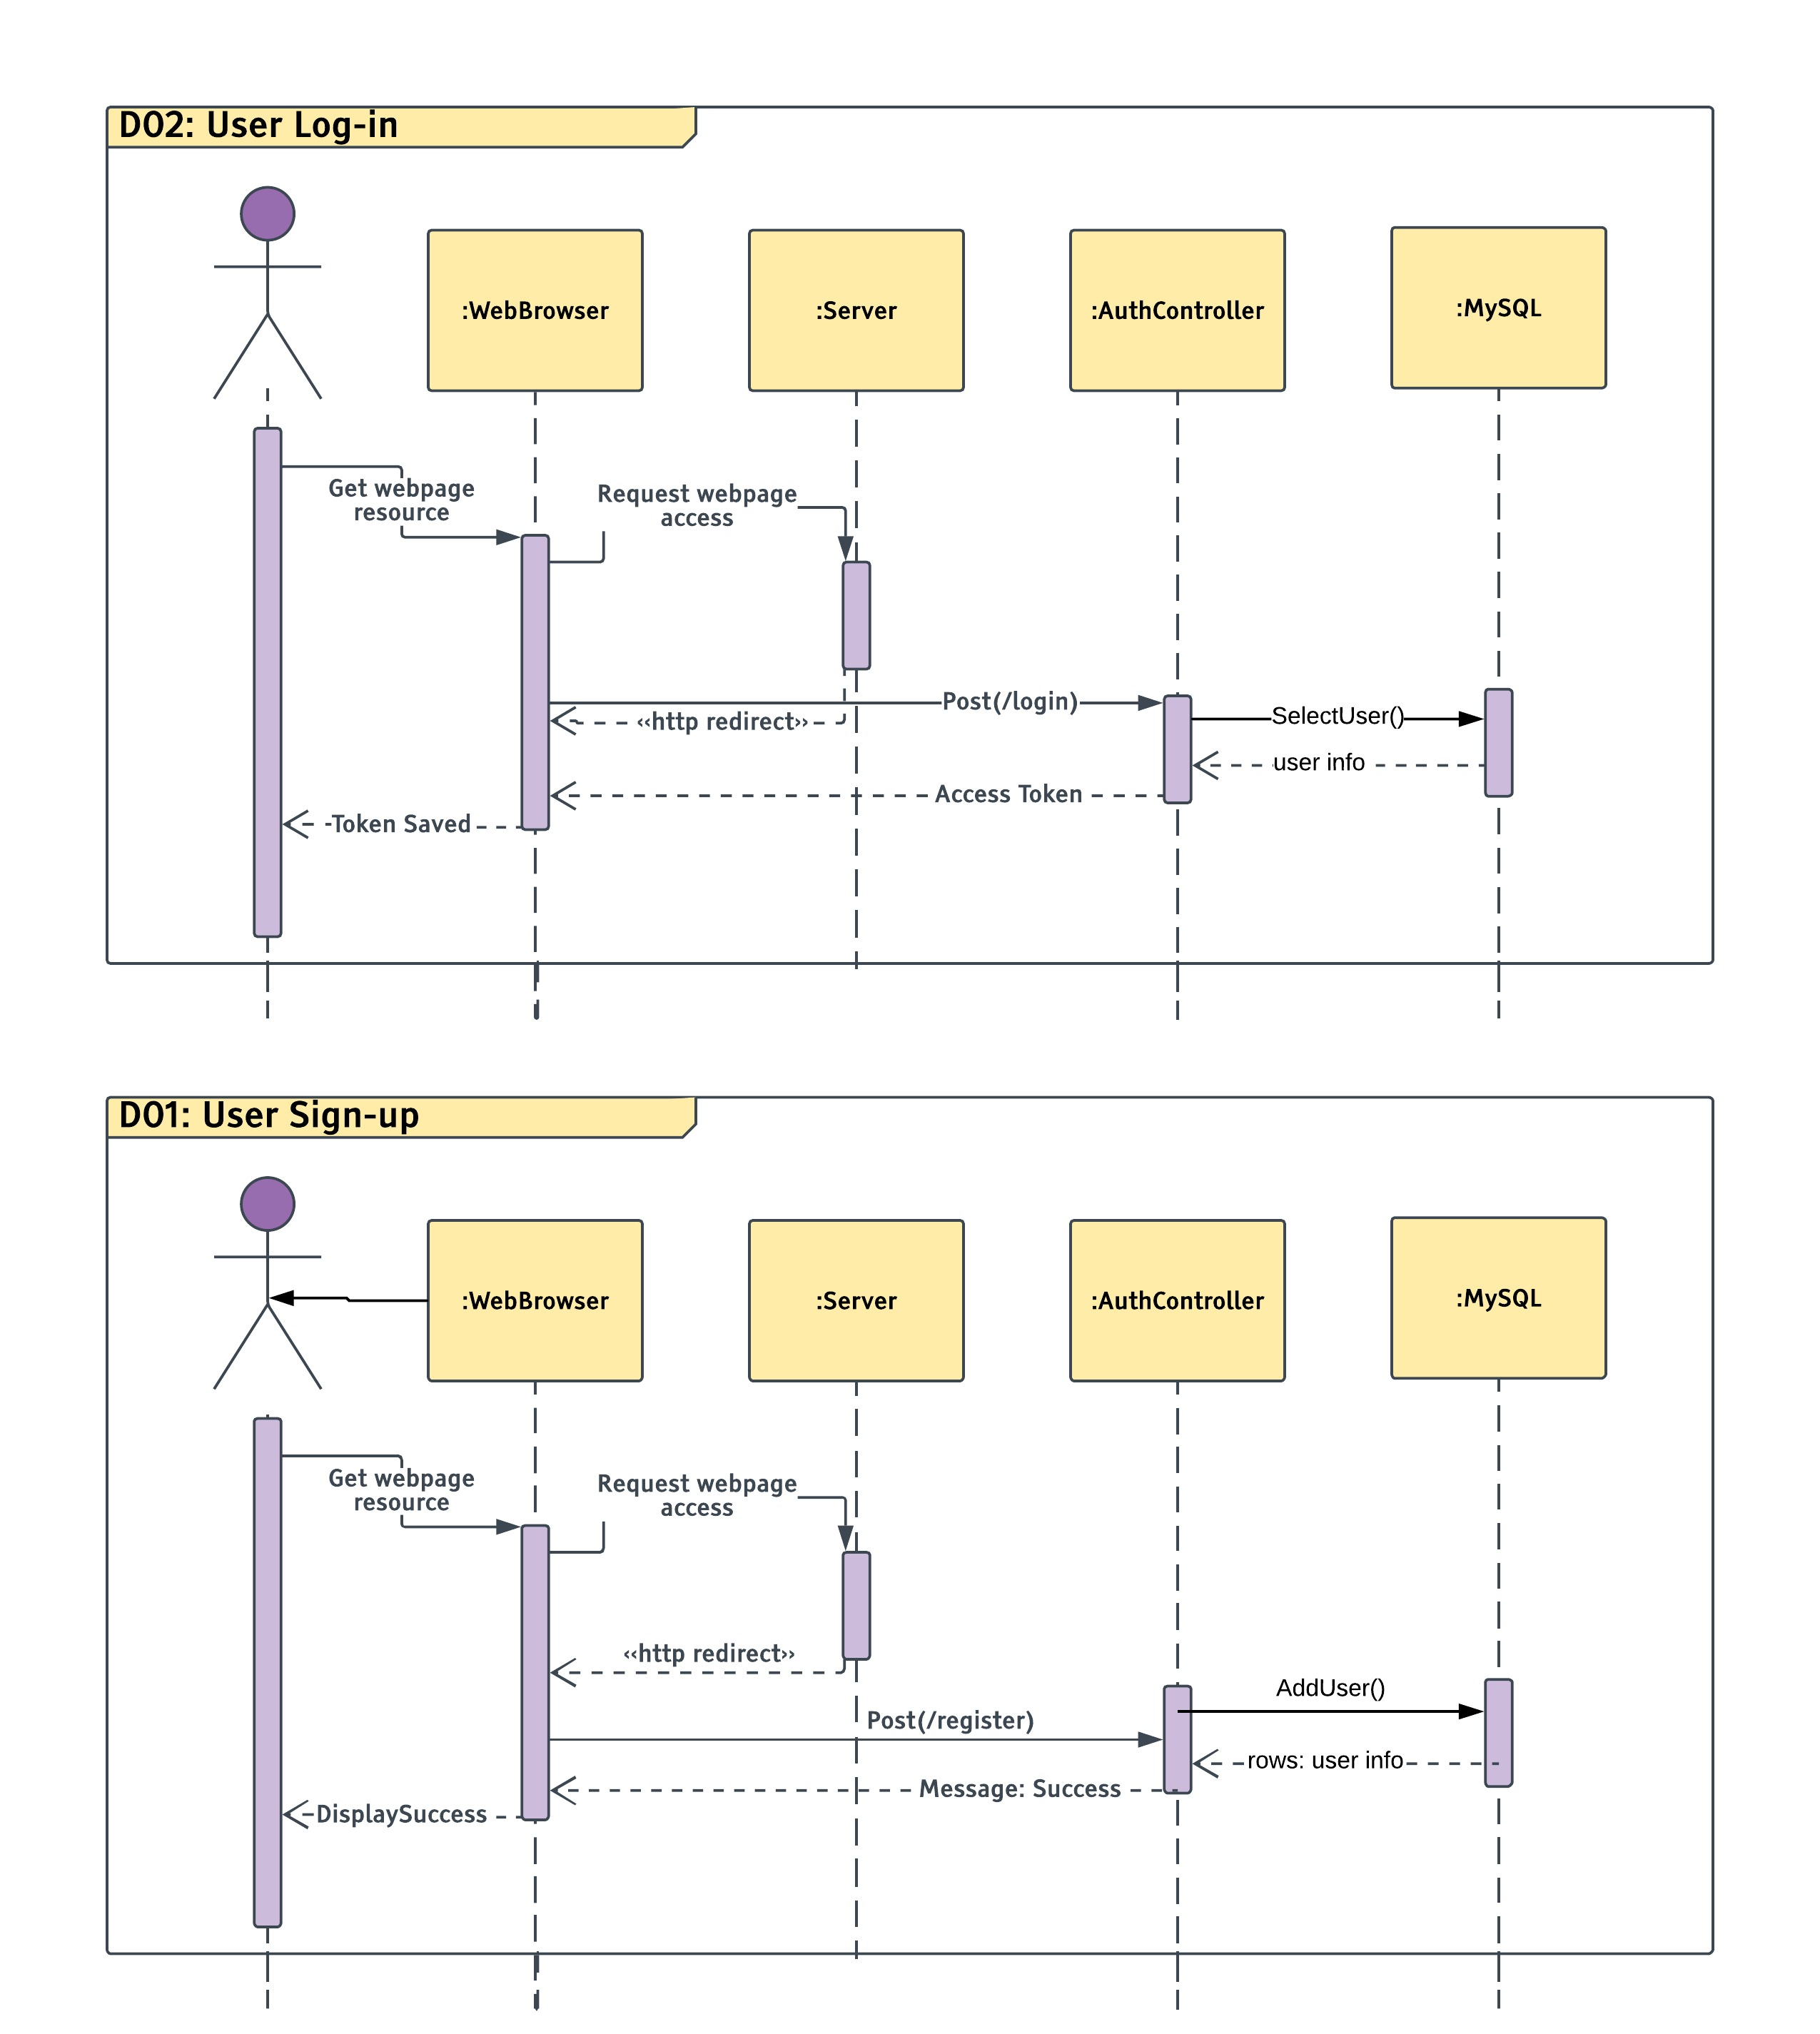
Figure 5 - User Sign-up Sequence Diagram - ID: D01
Figure 6 - User Log-in Sequence Diagram – ID: 02

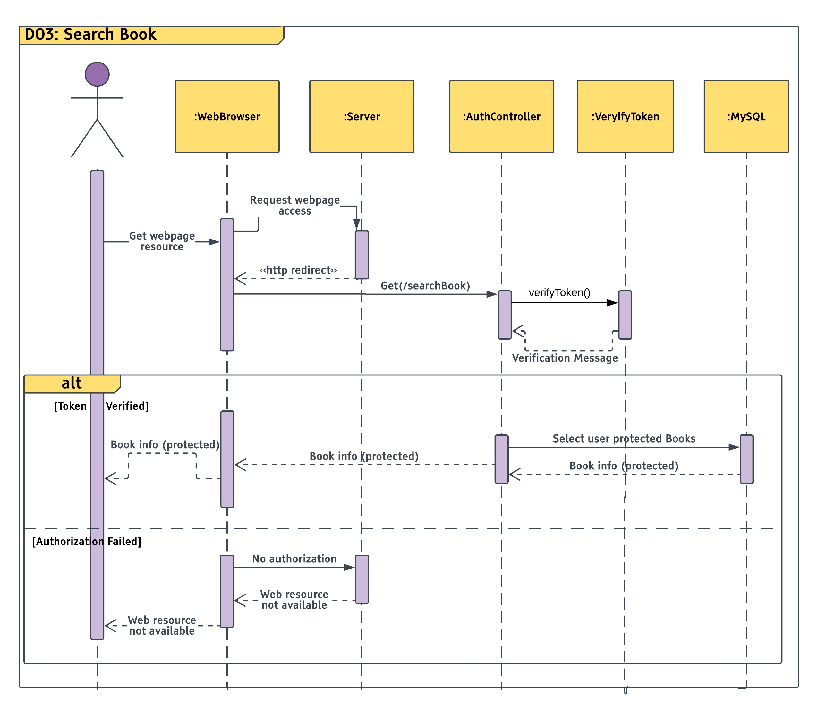
Figure 7 - Search Books Sequence Diagram – ID: D03

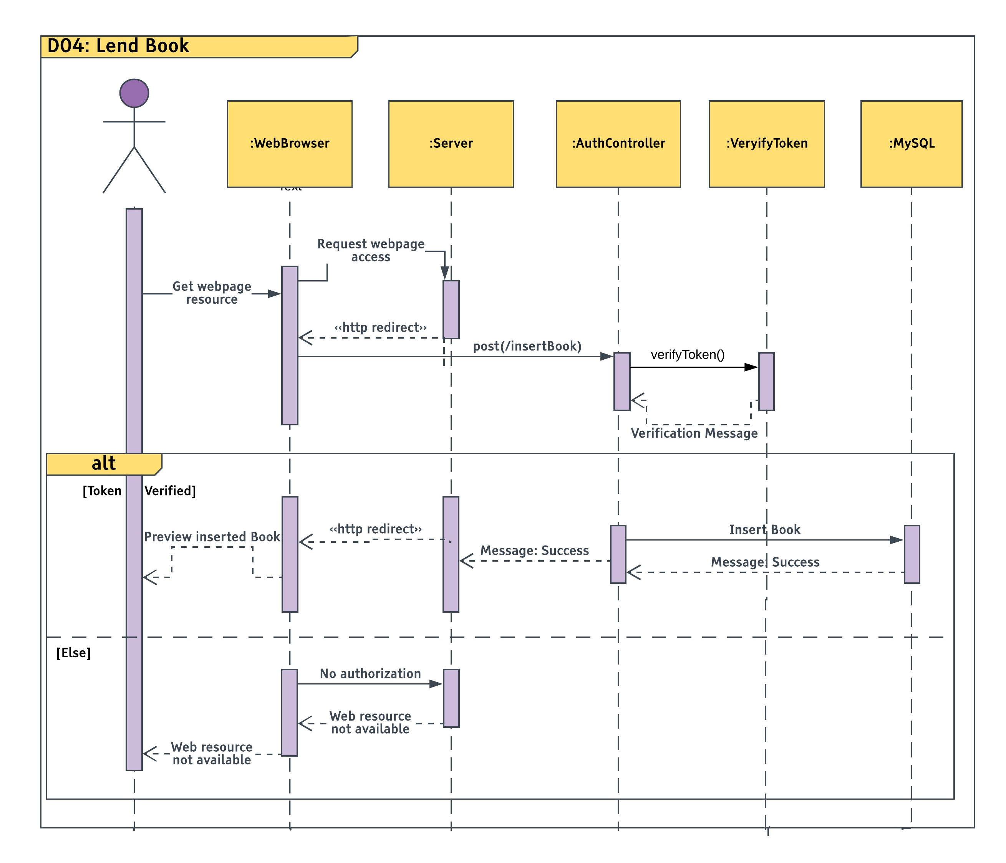
Figure 8 - Lend Book Sequence Diagram – ID: D04

Data Models

The following E-R diagram will show the various classes we have along with their attributes and they interact with each other.

N.B: The first attribute to be mentioned in each entity is the entities primary attribute.
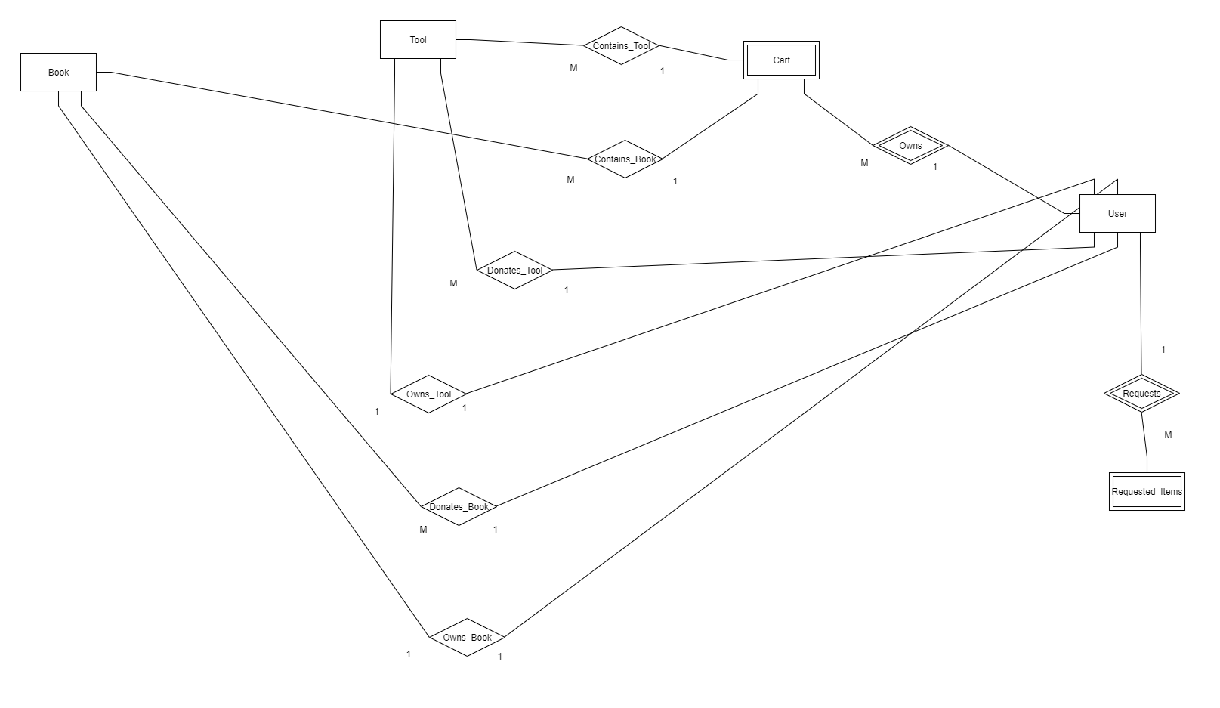
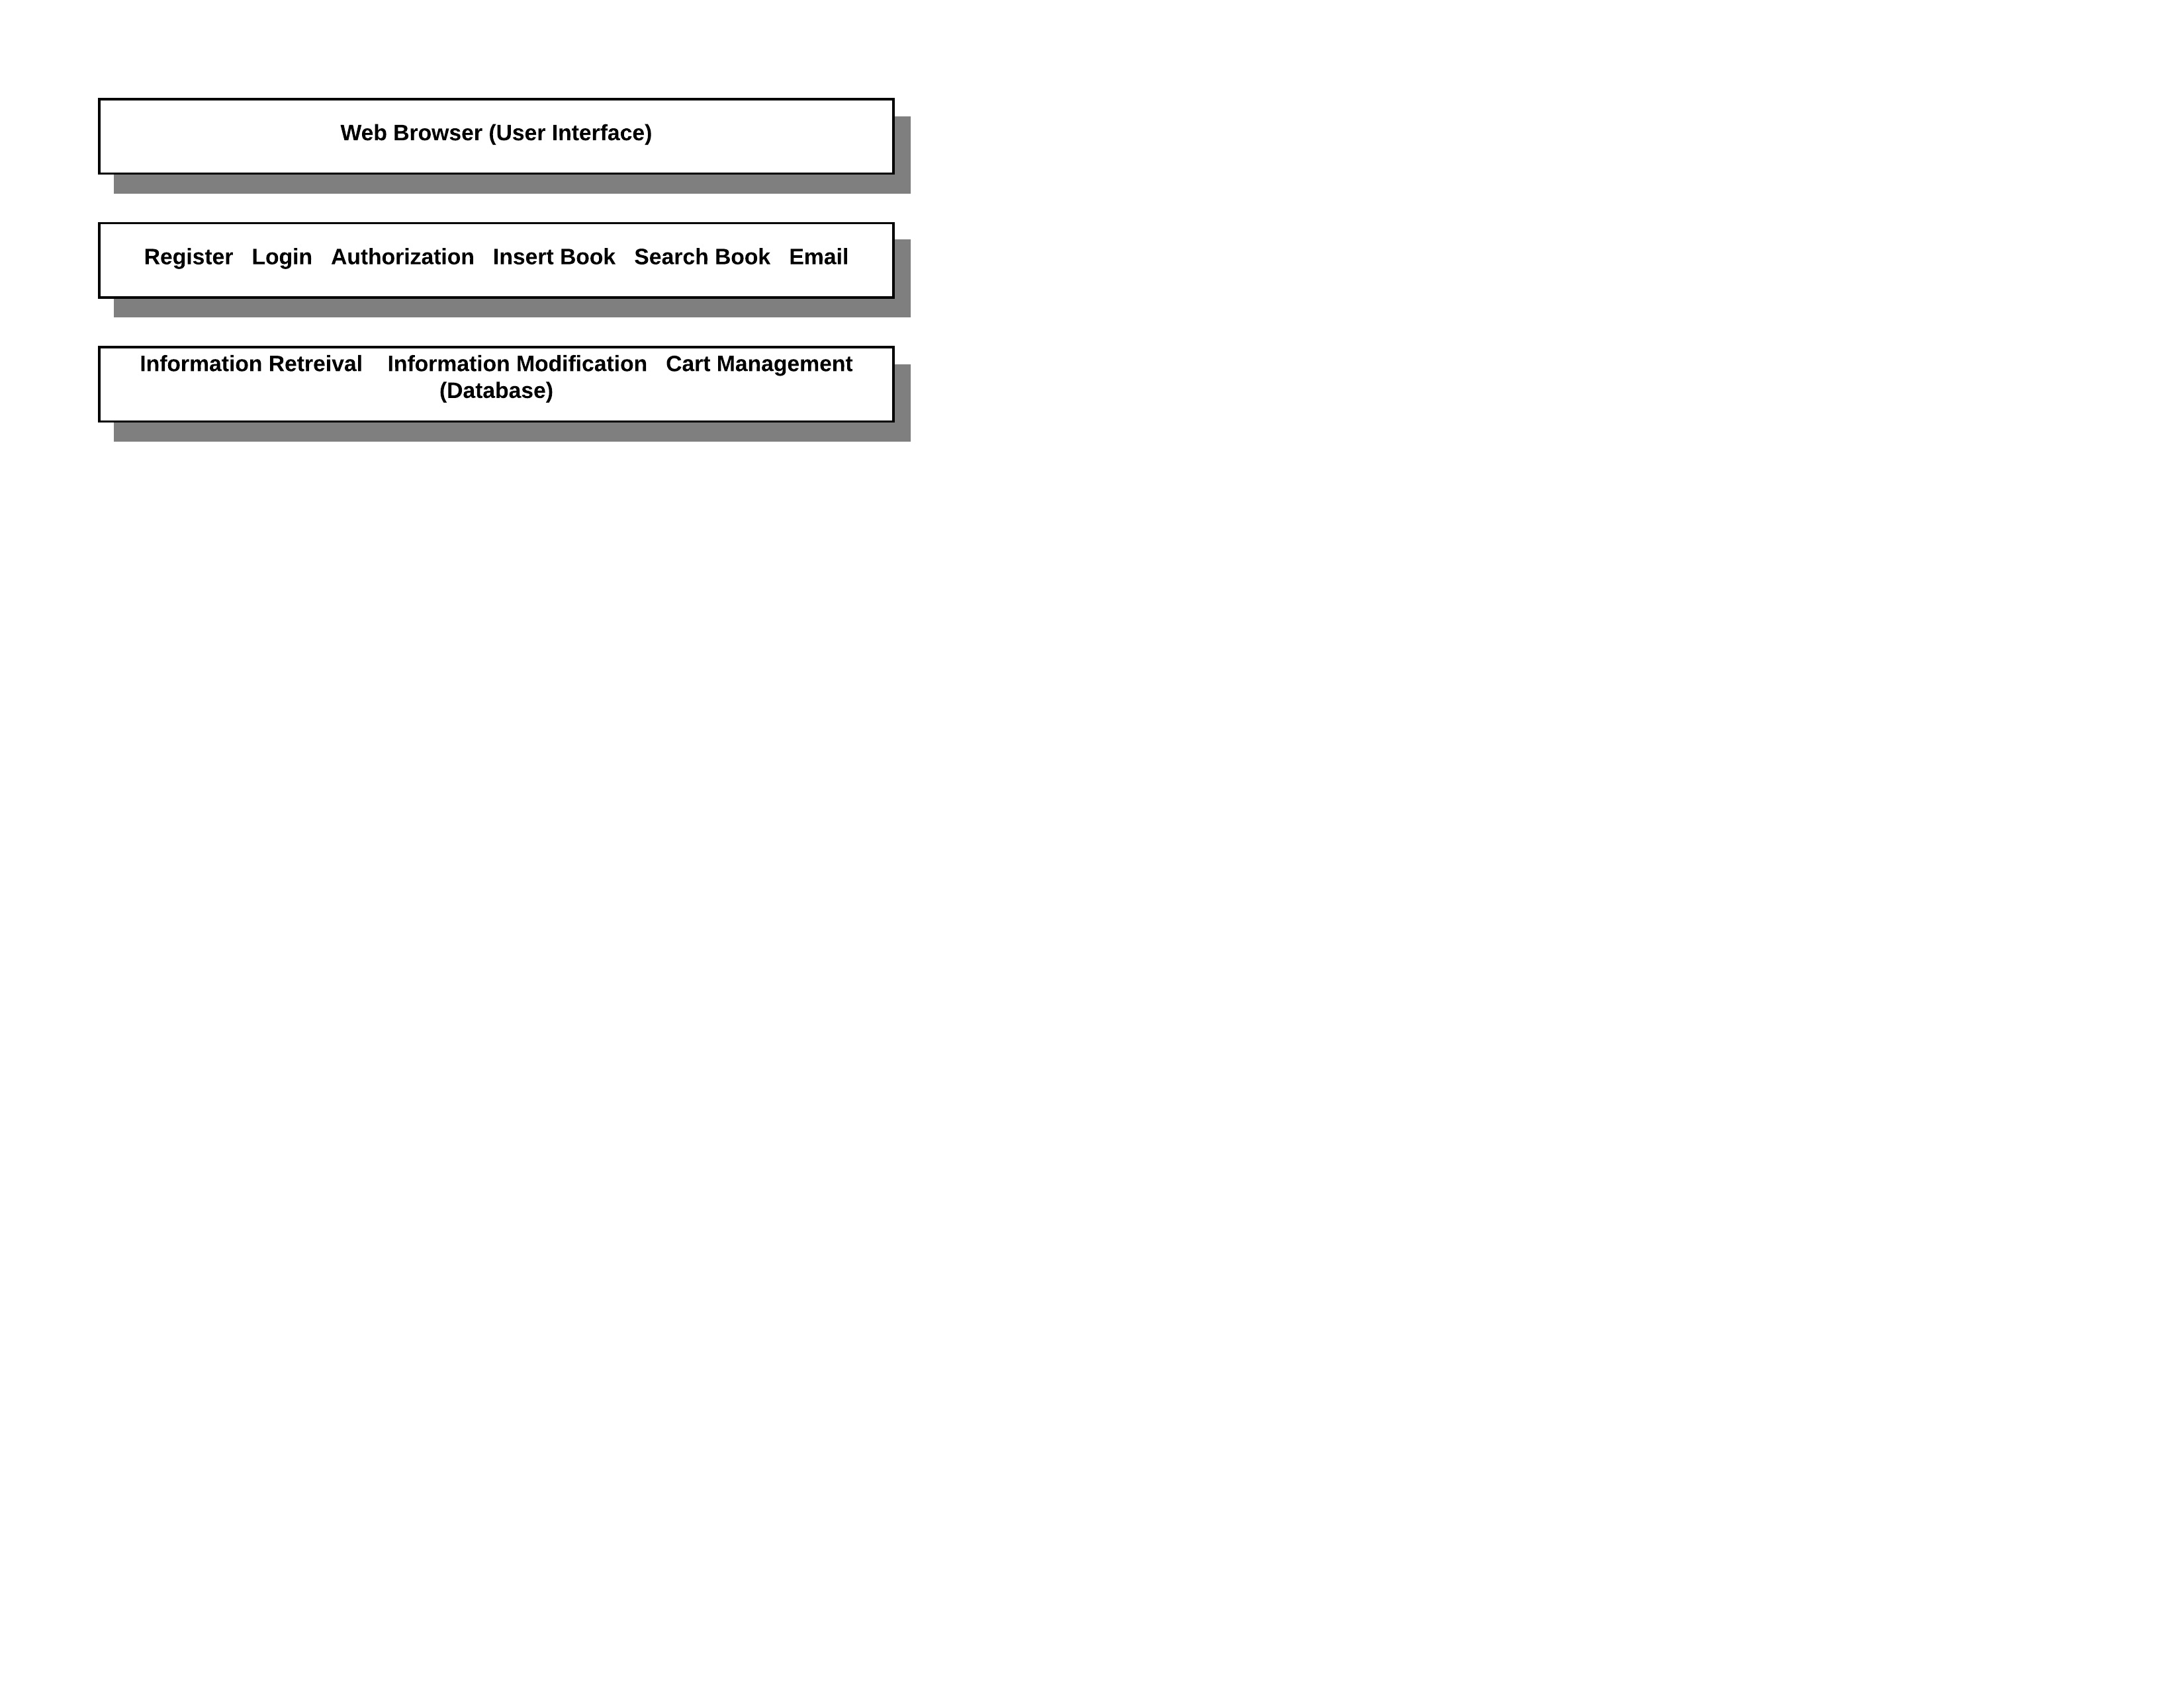
Figure 9 - Entity-Relationship Diagram (ERD)

Classes and their attributes:

1-Book:

Books are one of the main entities as they are the objects which the students will trade with each other. Such entities have various attributes that describe their uniqueness, status and to which students they will suit the most.

Attributes:
- Book_ID: A unique identifier for each book.
- Book_Status: Describes whether the book is currently with someone or with its owner.
- Code: MTH, CMP, ELC, CHM… etc.
- Edition: Edition Number of the book.
- Author: Books Author name.
- Title: Title of the book.
- Book_Duration: Duration of donation.
- Book_Owning_Duration: Duartion of borrowing the book.

2-Tool:

Tools are also from the main entities since many first-year students will need to borrow them from other students who won’t need them. Therefore, we need to store the data regarding their uniqueness, status, and other attributes that describes the tool.

Attributes:
- Tool_ID: A unique identifier for each book.
- Tool_Status: Describes whether the tool is currently with someone or with its owner.
- Type: Whether it’s a T-ruler, compass, triangle ruler… etc.
- Manufacturer: Samir & Ali, Alwan, Rotring… etc.
- Tool_Duration: Duration of donation.
- Tool_Owning_Duration: Duration of borrowing the tool.

3-User:

The user is always considered an important entity since we need to store data of the students who login to the website and donate/borrow the tools, so that we can facilitate their exchange processes without any inconveniences or delays.

Attributes:
- User_ID: Unique identifier for each user, will be used by the user to login to the website.
- Password: Passcode used by the user to complete his/her login to the website.
- Email: The electronic-mail the user will use to sign up on the site, it might be used to remember his password or change it.
- Phone: The number of the cellular phone that is used by the user.
- Year: Sophomore, Junior-1, Senior-2… etc.
- Department: CCE, EEE, CEM… etc.
- Join_Date: The date which the user signed up.

4-Cart:

The cart is the object that holds the item that a certain student wishes to borrow. In other words, it’s the gateway for the transaction between the students.

Attributes:
- Cart_ID: Unique identifier for the cart.
- Create_Date: The date which the cart was made.

5-Requested_Items:

Requested items are the items that a user can specifically request if he fails to find that the items are up for donation. E.g. if a student can’t find a specific math book for linear algebra he can specially request it so that any other student can see that request. Therefore, we are allowing to ask for help and ease it’s delivery.

Attributes:
- Request_No: Unique number that identifies each request.
- Request_Date: The date which the request was made by the user.

Relationships between classes and their attributes (if any existed):

1-Contains_Book:

Relationship between Book and Cart (Many to one). Shows that a cart may contain books inside it.

Attributes:
None.

2-Contains_Tool:

Relationship between Tool and Cart (Many to one). Shows that a cart may contain books inside it.

Attributes:
None.

3-Owns:

Identifying relationship between User and Cart (User identifies the cart, and the relation is one to many). Shows that a user can create a cart and control it and the items inside.

Attributes:
None.

4-Requests:

Identifying relationship between User and Requested_Items (User identifies Requested_Items, and the relation is one to many). Shows that a user can make special requests to find an item of desire, whether it was a book or tool.

Attributes:
None.

5-Donates_Book:

Relationship between Book and User (Many to one). Shows that a user can donate a book so that it can be added to the database.

Attributes:
Book_Duration: Describes the duration the book is up for donation.

6-Owns_Book:

Relationship between Book and User (One to one). Shows that a user can borrow a book for a certain period of time.

Attributes:
Book_Owning_Duration: The duration which the user is allowed to have the book for himself.

7-Donates_Tool:

Relationship between Tool and User (Many to one). Shows that a user can donate a tool so that it can be added to the database.

Attributes:
Tool_Duration: The duration a tool is up for donation.

8-Owns_Tool:

Relationship between Tool and user (One to one). Shows that a user can borrow a tool for a certain period of time.

Attributes:
Tool_Owning_Duration: The duration which the user is allowed to have the tool for himself.

System Deployment
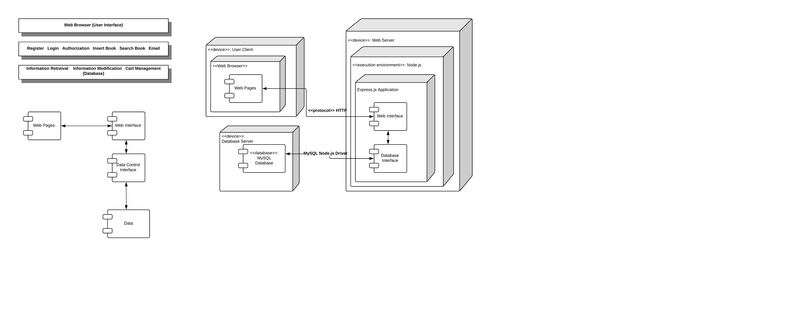
Figure 10 - Component Diagram Modeling the System’s Dependencies
Figure 11 - System Deployment Diagram
(run time processing nodes and the components that live on them)

Traceability to Requirements

Requirement | ID
User Sign up | UC01
User Login | UC02
Lend (Donate) a book | UC05
Search for a book | UC06
Choose whether to lend/donate book or tool | UC11
Table 2- Table of Requirement Identification

 | D01 | D02 | D03 | D04 | C01 | C02
UC01 | √ |  |  |  | √ | √
UC02 |  | √ |  |  | √ | √
UC05 |  |  | √ |  | √ | √
UC06 |  |  |  | √ | √ | √
UC11 |  |  |  |  |  | √
Table 3 – Traceability Matrix

